Natural Numbers Set
# Source: AI Source: Provided by: [Data Path: Persons Table -> ID Column: 1, Name_En Column: Motasem Essam] -> From: [ChatGPT] on [7/15/2026]
The Natural Numbers Set is the set of numbers used for counting and ordering objects. It is the most fundamental number set and serves as the starting point for the development of all other number sets.
Natural numbers are used extensively in arithmetic, algebra, number theory, computer science, engineering, statistics, and many everyday applications.

Definition
# Source: AI Source: Provided by: [Data Path: Persons Table -> ID Column: 1, Name_En Column: Motasem Essam] -> From: [ChatGPT] on [7/15/2026]
The Natural Numbers Set is the collection of positive counting numbers.
It is commonly denoted by
$$\boxed{N}$$
and is defined as
$$\boxed{N=\{1,2,3,4,5,…\}}$$
The ellipsis ($…$) indicates that the set continues infinitely.
Note: Some textbooks define $N=\{0,1,2,3,…\}$. When this convention is used, the definition should be stated explicitly. In this guide, 0 is not included in the natural numbers.

Set Notation
# Source: AI Source: Provided by: [Data Path: Persons Table -> ID Column: 1, Name_En Column: Motasem Essam] -> From: [ChatGPT] on [7/15/2026]
Roster notation:
$$N=\{1,2,3,4,5,…\}$$
Set-builder notation:
$$\boxed{N=\{ x∈Z∣x>0 \}}$$
This means:
"The set of all integers greater than zero."

Examples
Natural numbers include
$$1, 2, 3, 4, 5, 10, 25, 100, 1000$$

Non-Examples
# Source: AI Source: Provided by: [Data Path: Persons Table -> ID Column: 1, Name_En Column: Motasem Essam] -> From: [ChatGPT] on [7/15/2026]
The following are not natural numbers:
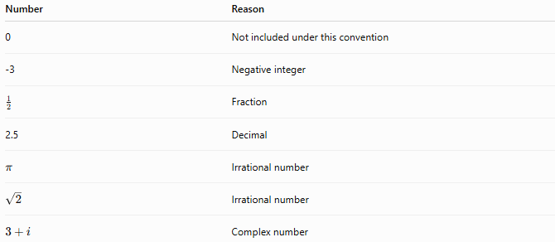
Number | Reason
0 | Not included under this convention
-3 | Negative integer
$$\frac{1}{2}$$ | Fraction
2.5 | Decimal
$$π$$ | Irrational number
$$\sqrt{2}$$ | Irrational number
$$3+i$$ | Complex number

Characteristics
# Source: AI Source: Provided by: [Data Path: Persons Table -> ID Column: 1, Name_En Column: Motasem Essam] -> From: [ChatGPT] on [7/15/2026]
Natural numbers are:
- Positive
- Whole
- Countable
- Infinite in quantity
- Ordered
- Discrete (no values between consecutive natural numbers)

Properties
# Source: AI Source: Provided by: [Data Path: Persons Table -> ID Column: 1, Name_En Column: Motasem Essam] -> From: [ChatGPT] on [7/15/2026]
Natural numbers satisfy the following properties.
Closure
Closed under:
- Addition
$$3+5=8$$
- Multiplication
$$4×6=24$$
Not closed under:
- Subtraction
$$3-5=-2$$
- Division
$$5÷2=2.5$$

Commutative Property
Addition
$$a+b=b+a$$
Multiplication
$$ab=ba$$

Associative Property
Addition
$$\left(a+b)+c=a+(b+c\right)$$
Multiplication
$$\left(ab)c=a(bc\right)$$

Distributive Property
$$a(b+c)=ab+ac$$

Ordering
Natural numbers are arranged in increasing order:
$$1<2<3<4<5<⋯$$
Every natural number has a unique position in this sequence.

Successor
Every natural number has exactly one successor.
If
$$n∈N,$$
then its successor is
$$\boxed{n+1}$$
Examples:
- Successor of 5 is 6.
- Successor of 100 is 101.

Predecessor
Every natural number except 1 has a predecessor.
Examples:
- Predecessor of 8 is 7.
- Predecessor of 50 is 49.
The number 1 has no predecessor within $N$.

Cardinality
The natural numbers form an infinite set.
Its cardinality is
$$\boxed{ℵ_{0}}$$
called countably infinite.

Relationship to Other Number Sets
# Source: AI Source: Provided by: [Data Path: Persons Table -> ID Column: 1, Name_En Column: Motasem Essam] -> From: [ChatGPT] on [7/15/2026]
$$\boxed{N⊂W⊂Z⊂Q⊂R⊂C}$$
Every natural number is also:
- a whole number,
- an integer,
- a rational number,
- a real number,
- and a complex number (with imaginary part equal to zero).

Examples
# Source: AI Source: Provided by: [Data Path: Persons Table -> ID Column: 1, Name_En Column: Motasem Essam] -> From: [ChatGPT] on [7/15/2026]
Example 1
Determine whether
$$27$$
is a natural number.
Yes.
$$27∈N$$

Example 2
Determine whether
$$-8$$
is a natural number.
No.
Negative numbers are not natural numbers.

Example 3
Determine whether
$$\frac{3}{4}$$
is a natural number.
No.
Fractions are not natural numbers.

Example 4
Determine whether
$$0$$
is a natural number.
Under this convention:
No.

Example 5
Largest natural number?
There is no largest natural number because
$$n+1>n$$
for every natural number.

Applications
# Source: AI Source: Provided by: [Data Path: Persons Table -> ID Column: 1, Name_En Column: Motasem Essam] -> From: [ChatGPT] on [7/15/2026]
Natural numbers are used in:
- Counting objects
- Ranking
- Number theory
- Arithmetic
- Combinatorics
- Algorithms
- Programming
- Statistics
- Data structures
- Scientific computing

Real-Life Applications
# Source: AI Source: Provided by: [Data Path: Persons Table -> ID Column: 1, Name_En Column: Motasem Essam] -> From: [ChatGPT] on [7/15/2026]
Natural numbers are used for:
- Counting people
- Counting books
- House numbers
- Seat numbers
- Rankings
- Item quantities
- Inventory counts
- Student IDs
- Sports scores
- Page numbers

Common Mistakes
# Source: AI Source: Provided by: [Data Path: Persons Table -> ID Column: 1, Name_En Column: Motasem Essam] -> From: [ChatGPT] on [7/15/2026]
- Assuming that 0 is always a natural number.
- Confusing natural numbers with whole numbers.
- Assuming fractions belong to the natural numbers.
- Assuming decimals are natural numbers.
- Forgetting that the set is infinite.

Key Points
# Source: AI Source: Provided by: [Data Path: Persons Table -> ID Column: 1, Name_En Column: Motasem Essam] -> From: [ChatGPT] on [7/15/2026]
- Natural numbers are counting numbers.
- They are positive integers.
- They begin with 1 under this convention.
- They continue indefinitely.
- They form the smallest commonly used infinite number set.

Natural Numbers vs. Whole Numbers
# Source: AI Source: Provided by: [Data Path: Persons Table -> ID Column: 1, Name_En Column: Motasem Essam] -> From: [ChatGPT] on [7/15/2026]
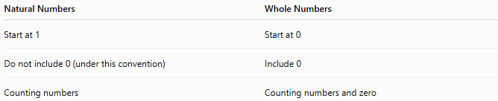
Natural Numbers | Whole Numbers
Start at 1 | Start at 0
Do not include 0 (under this convention) | Include 0
Counting numbers | Counting numbers and zero

Natural Numbers vs. Integers
# Source: AI Source: Provided by: [Data Path: Persons Table -> ID Column: 1, Name_En Column: Motasem Essam] -> From: [ChatGPT] on [7/15/2026]
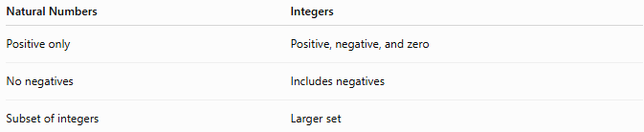
Natural Numbers | Integers
Positive only | Positive, negative, and zero
No negatives | Includes negatives
Subset of integers | Larger set

Natural Numbers vs. Rational Numbers
# Source: AI Source: Provided by: [Data Path: Persons Table -> ID Column: 1, Name_En Column: Motasem Essam] -> From: [ChatGPT] on [7/15/2026]
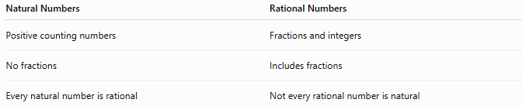
Natural Numbers | Rational Numbers
Positive counting numbers | Fractions and integers
No fractions | Includes fractions
Every natural number is rational | Not every rational number is natural

Conclusion
# Source: AI Source: Provided by: [Data Path: Persons Table -> ID Column: 1, Name_En Column: Motasem Essam] -> From: [ChatGPT] on [7/15/2026]
The Natural Numbers Set, denoted by $N$, is the set of positive counting numbers
$$N=\{1,2,3,4,…\}.$$
It is the foundation of arithmetic and the starting point for the construction of larger number sets. Natural numbers are infinite, ordered, discrete, and closed under addition and multiplication. They are used extensively for counting, ordering, computation, and mathematical reasoning, making them one of the most fundamental concepts in mathematics.

